Project Design Phase-I
Solution Architecture

Date | 19 september2022
Team ID | PNT2022TMID41194
Project Name | Project – web fishing detection
Maximum Marks | 4Marks

Architecture:

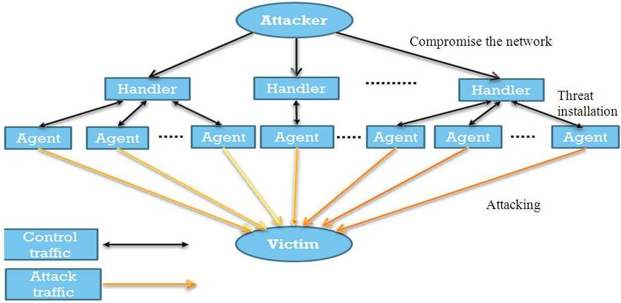

USER STORIES:

- An attacker should not be able to purchase items without paying.
- An attacker should not be able to hack the site using known vulnerabilities.
- A user should not be able to see another user’s personal information.
- A user should not be able to send spam on the contact form.
- Many simultaneous users should not be able to crash the website.
- The admin should not be able to shut down the server accidentally.
- A user should not be able to add so many items to a shopping basket that the items are marked as reserved, and other users cannot buy them.
- A user should not be able to use premium features without paying.

